**HAZARDOUS AREA MONITORING FOR INDUSTRIAL PLANT POWERED BY IOT**

**INTRODUCTION**

* 1. **PROJECT OVERVIEW**

If the damage that occurs in hazardous areas can result in the loss of property or lives. So **monitoring of such areas can help in easy monitoring of the hazardous areas**. There can be smart devices integrated at the hazardous areas that can help in detecting any fishy things that can occur in the particular area.

[Hazardous Area Monitoring for Industrial Plants](https://partheniumprojects.com/hazardous-area-monitoring-for-industrial-plants/) is a project report that focuses on the necessity of the monitoring of hazardous areas in industrial plants. Industrial plants are the ones that contain both hazardous and non-hazardous areas. The monitoring of the hazardous areas in industrial plants is important from time to time. If the damage that occurs in hazardous areas can result in the loss of property or lives. So monitoring of such areas can help in easy monitoring of the hazardous areas. There can be smart devices integrated at the hazardous areas that can help in detecting any fishy things that can occur in the particular area.

* 1. **PURPOSE**

A hazardous area is any area with an atmosphere containing, or potentially containing, gases, vapors or dust which are flammable or explosive. These areas are rigorously analyzed with condition monitoring when installing equipment minimize the risk to individuals and assets.It is crucial that equipment operating in these conditions are effectively monitored to pre-empt any issues before they occur. Unlike most industries, these issues not only result in downtime, but present a significant safety risk.

**2.LITERATURE SURVEY**

The use of digital solutions can offer a viable and safe way to address the challenges involved with hazardous area monitoring, minimizing the need for manual inspection and intervention.

One solution, motion fleet management (MFM), can provide a digital solution for data collection and condition monitoring of industrial assets. Using cloud computing, operators can access the operational status of equipment including motors and drives in any industry or location. MFM collects and processes data regularly both at the edge and in the cloud to generate important information on asset operation. Operators can use these insights to develop predictive maintenance plans and carry out condition-based maintenance.

Periodic data collection gives a more thorough overview of asset condition, removing the need for maintenance teams to carry out observations and collect data manually. Having access to this data more frequently can allow maintenance teams to make informed decisions quickly and minimize unplanned.

**2.1 EXISTING PROBLEM**

Certain areas in industrial settings are classified as hazardous due to the presence of flammable gases, vapors, dusts, or fibers. This article describes various ways to design these panels so they do not become potential ignition sources, using the International Electrotechnical Commission (IEC) zone hazardous area classification system for this purpose.

Figure 1 depicts how the IEC zone system classifies areas based on the ignitable concentrations of flammable gases or vapors. Zone 0 is the most hazardous area, followed by Zone 1, and then Zone 2. It is much more expensive, complex, and time consuming to design, fabricate, and maintain control panels to use in Zone 0 rather than Zone 1 or 2. So, the first step is to locate control panels outside of Zone 0 areas wherever possible. This can often be accomplished by moving panels just a short distance, often as little as a few feet

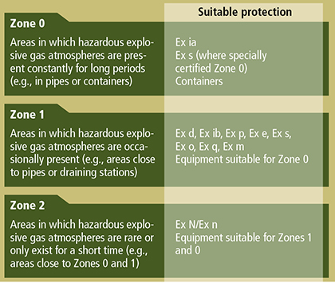

**2.2 REFERENCES**

[1] Ganga, D., & Ramachandran, V. (2018). IoT-based vibration analytics of Electrical Machines. IEEE Internet of Things Journal, 5(6), 4538–4549. https://doi.org/10.1109/jiot.2018.2835724 [2] Dai, B. (2019). Design of complex wind power generation parameter control system based on embedded control combined with internet of things. Web Intelligence, 17(2), 131–139. https://doi.org/10.3233/web-190407 [3] Wang, X., & Cai, S. (2020). An efficient named-data-networking-based IOT Cloud Framework. IEEE Internet of Things Journal, 7(4), 3453–3461. https://doi.org/10.1109/jiot.2020.2971009 [4] Saha, S., & Majumdar, A. (2017). Data Centre temperature monitoring with ESP8266 based wireless sensor network and cloud based dashboard with Real Time Alert System. 2017 Devices for Integrated Circuit (DevIC). https://doi.org/10.1109/devic.2017.8073958 [5] Chawla, Y. P. (2022). Wi-Fi Computing Network empowers Wi-Fi Electrical Power Network. Cloud Computing Enabled Big-Data Analytics in Wireless Ad-Hoc Networks, 49–64. <https://doi.org/10.1201/9781003206453-4>

**2.3 PROBLEM STATEMENT DEFINITION**

**1. CUSTOMER SEGMENT(S)**[Hazardous Area Monitoring for Industrial Plants](https://partheniumprojects.com/hazardous-area-monitoring-for-industrial-plants/) is a project report that focuses on the necessity of the monitoring of hazardous areas in industrial plants.

To reduce the Energy losses in Lighting system with effective control.All industries are different, with different operations and needs. There are also different lighting requirements for the various types of industrial activities in the lighting standard, as well as in other applications, and it is difficult to come up with a general recommendation for light control. A well planned lighting design together with a well-executed lighting control solution means optimized lighting for a specific activity is achievable.Whatever the requirements, it is smart to think lighting control at the planning stage, and in industrial and warehouse applications, we believe that a control system is the obvious, and in many cases, the only choice. However, to get maximum benefit of a control system it needs to be project specific. You must know how the industry works and how different areas are used during working hours. For example, it is important to establish if there is natural light? During what times, and for how long are staff present in certain areas? Are there areas of greater occupancy? How much activity is there in, say the aisles of the warehouse? If you do not ask these questions, you will not get the best results from the lighting control system.

**3.IDEATION &PROPOSED** 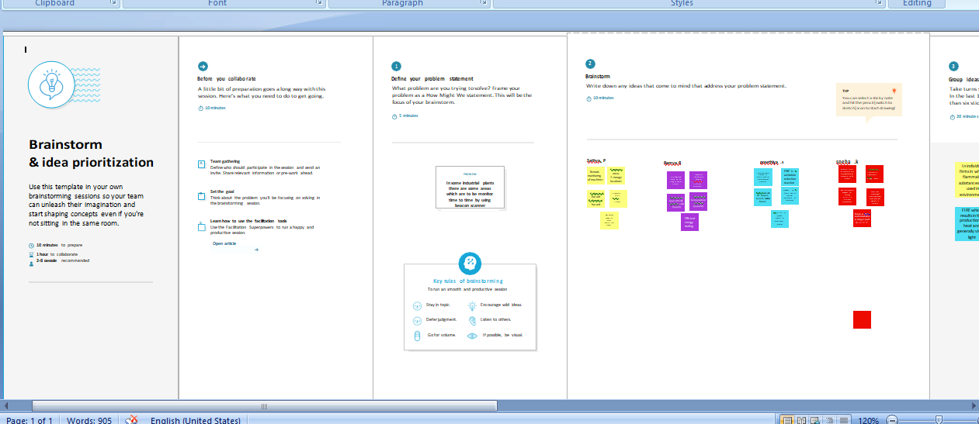

**3.1 EMPATHY MAP**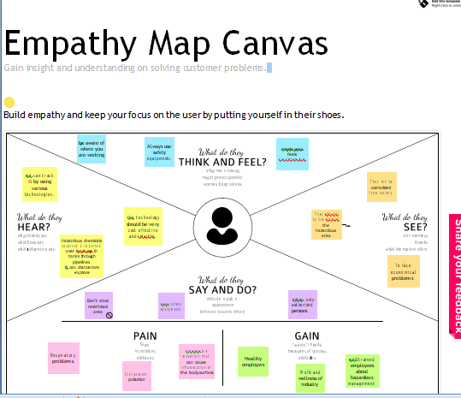

**3.2 IDEATION &BRAINSTORMING**

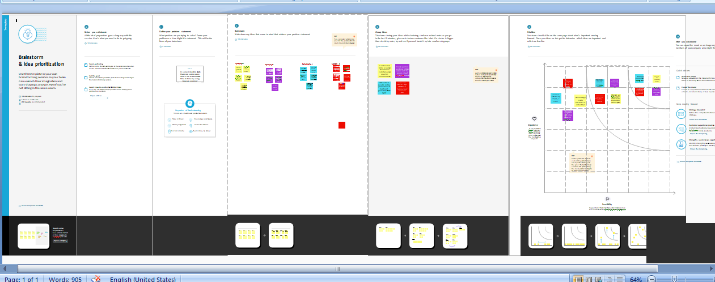

**3.3 .PROPOSED SOLUTION**

|  |  |  |
| --- | --- | --- |
| **S.No.** | **Parameter** | **Description** |
| **1** | Problem Statement (Problem to be solved) | Through this, we can monitor the temperature  Parameter of the hazardous areas in industrial Plants. |
| **2** | Idea / Solution description | The industrial area is integrated with smart beacon devices which will be broadcasting the temperature of that particular area.  Every person working in those areas will be given smart wearable devices will be acting as beacon scanners.  Whenever the person goes near the beacon  Scanners he can view the temperature is high , he will receive the alerts to the mobile through SMS using API.  Through this wearable device, the data is sent to the cloud and the dashboard, the admins of that particular plant can view the data and take necessary precautions if required. |
| **4** | Social Impact / Customer Satisfaction | Avoid large scale hazards in industries and save environment & people |
| **5** | Business Model (Revenue Model) | Sell BLE beacons with indoor positions in service are build in indoor position is service as service |

**3.4.PROBLEM SOLUTIONFIT**

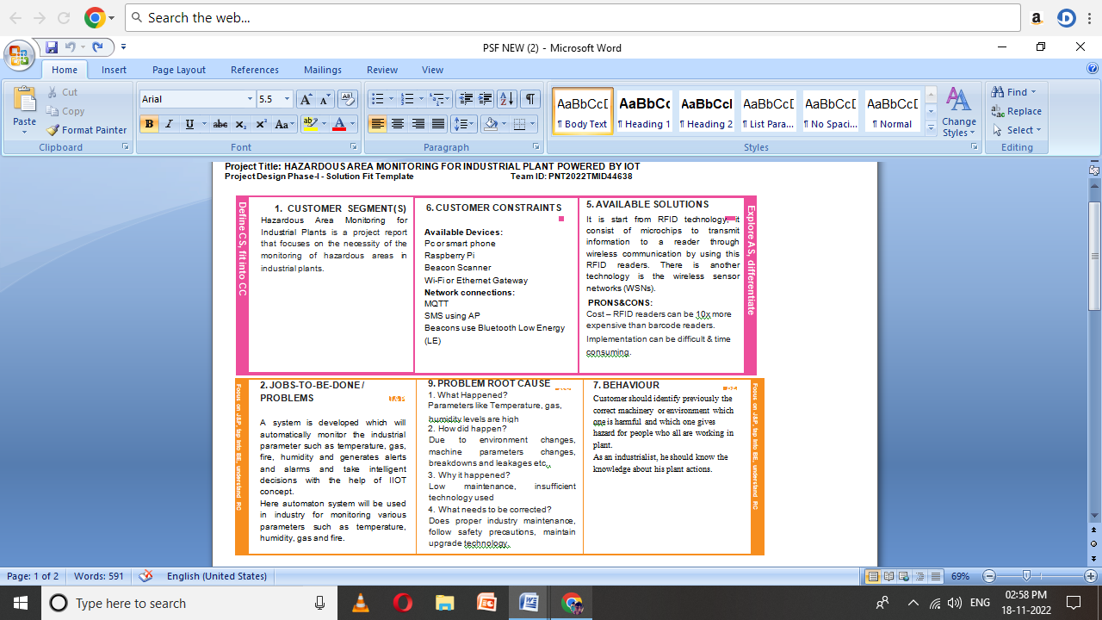

**4.REQUIREMENT ANALYSIS**

**4.1.FUNCTIONAL REQUIREMENT**

|  |  |  |
| --- | --- | --- |
| **FR No.** | **Functional Requirement (Epic)** | **Sub Requirement (Story / Sub-Task)** |
| 1 | User Registration | Registration through Form Registration through Gmail  Registration through LinkedIN |
| 2 | User Confirmation | Confirmation via Email  Confirmation via OTP |

**4.2.NON-FUNCTIONAL REQUIREMENT**

|  |  |  |
| --- | --- | --- |
| **FR No.** | **Non-Functional Requirement** | **Description** |
| NFR-1 | **Usability** | The industrial area is integrated with smart beacon devices which will be broadcasting the temperature of that particular area.  Every person working in those areas will be given smart wearable devices will be acting as beacon scanners.  Whenever the person goes near the beacon  Scanners he can view the temperature is high , he will receive the alerts to the mobile through SMS using API.  Through this wearable device, the data is sent to the cloud and the dashboard, the admins of that particular plant can view the data and take necessary precautions if required |
| NFR-2 | **Security** | Avoid large scale hazards in industries and save environment & people |
| NFR-3 | NFR-3 | Sell BLE beacons with indoor positions in service are build in indoor position is service as service |

**5.PROJECT DESIGN**

**5.1 DATA FLOW DIAGRAM**

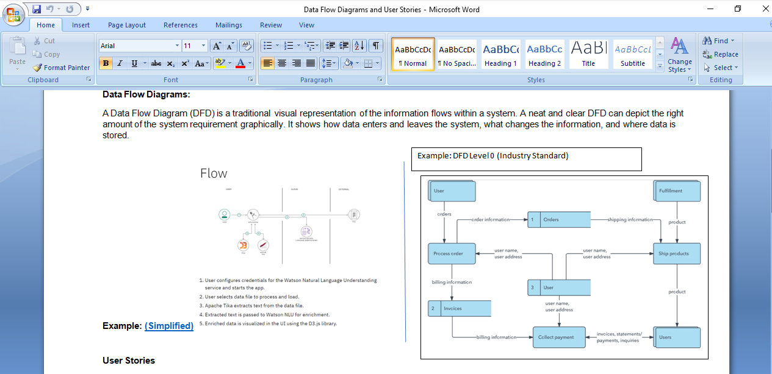

**5.2 SOLUTION&TECHNICAL ARCHITECTURE**

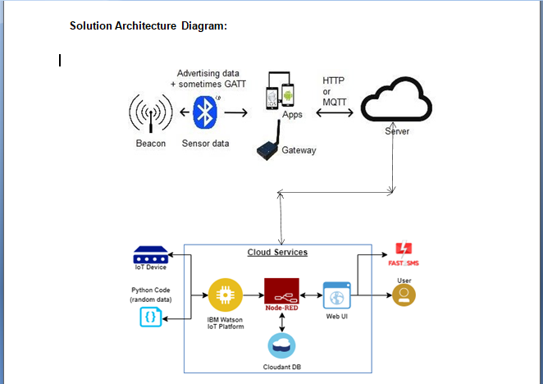

**5.3 USER STORIES**

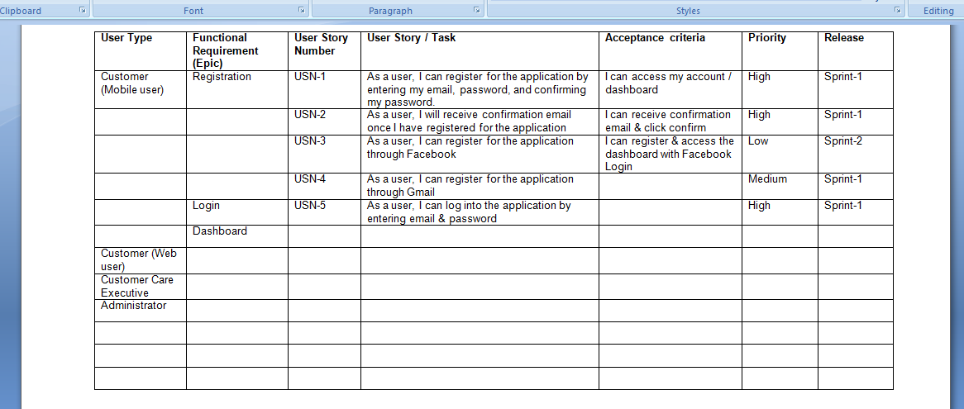

**6.PROJECT PLANNING&SCHEDULING**

**6.1 SPRINT PLANNING&ESTIMATION**

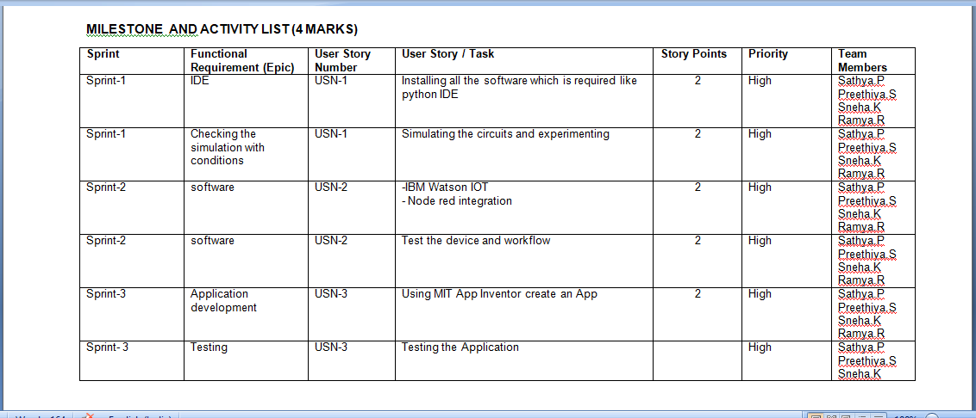

**6.2 SPRINT DELIVERY SCHEDULE**

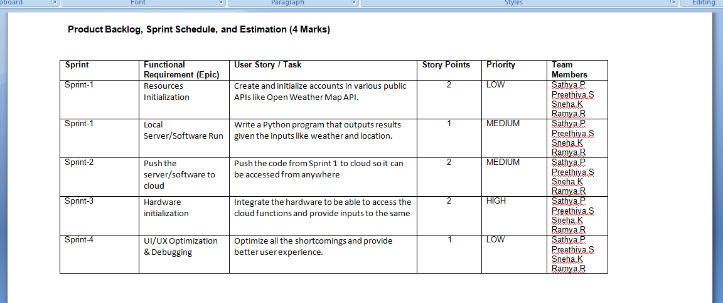

**7.CODING&SOLUTION**

def run(self):

"""

Called when the thread is running.

Monitors the 7 pin harness state and updates the SK6812 leds as needed.

"""

while not self.die:

if self.is_driving_state:

if self.brake_lights_state:

self.do_brake()

elif self.right_blinker_state:

self.do_right_blinker()

elif self.left_blinker_state:

self.do_right_blinker()

if self.reverse_lights_state:

self.do_reverse()

if self.marker_lights_state:

self.do_marker()

sleep(0.05)

else:

sleep(1)

def do_brake(self):

# check if hazard lights are on first...

# Then call self.do_hazard(), else do this:

if self.brake_lights_state:

self.set_lights(self.leds['rear_right_blinker'], BRAKE_COLOR)

self.set_lights(self.leds['rear_left_blinker'], BRAKE_COLOR)

else:

self.set_lights(self.leds['rear_right_blinker'], OFF_COLOR)

self.set_lights(self.leds['rear_left_blinker'], OFF_COLOR)

**7.1 FEATURES**

The problem I'm having now is to detect if the hazard lights are on, that is if 'self.brake_lights_state' is changing at a regular cadence.

Assuming the hazard lights flash on for 400ms and off for 400ms, how would I detect this? I want to prevent false positives from tapping the brakes. For example when backing up the travel trailer, it's common to feather the brakes/gas a bit. So, I'd only want the hazards to turn on say after it detects the lights flashing 3 or 4 times within that nearly exact 400ms time interval. I say nearly exact, because sometimes for some weird reason, every 5th blink the tow vehicle has a speed of 400ms on, and 325ms speed off.

I'm completely over my head. I'm guessing I could use deque collection and time() somehow to track when the brake_lights_state changes.

Does anyone have any ideas on where to get started? I'm running this all within a thread and use the run() method

**8.TESTING**

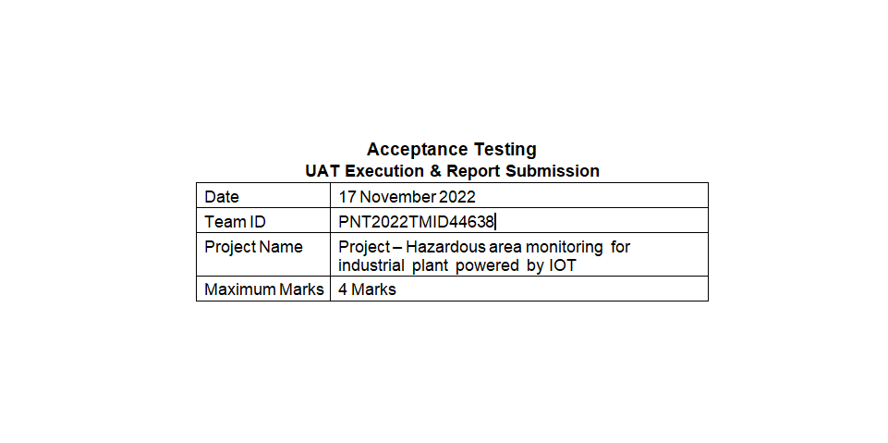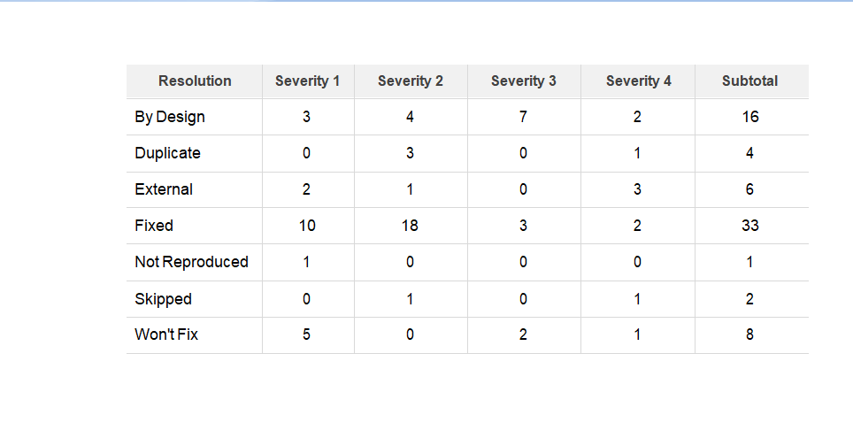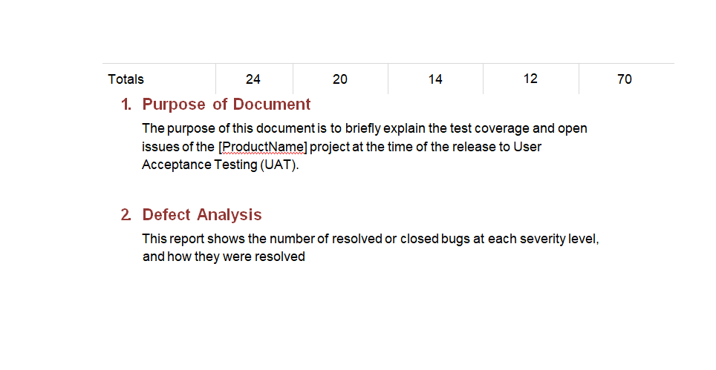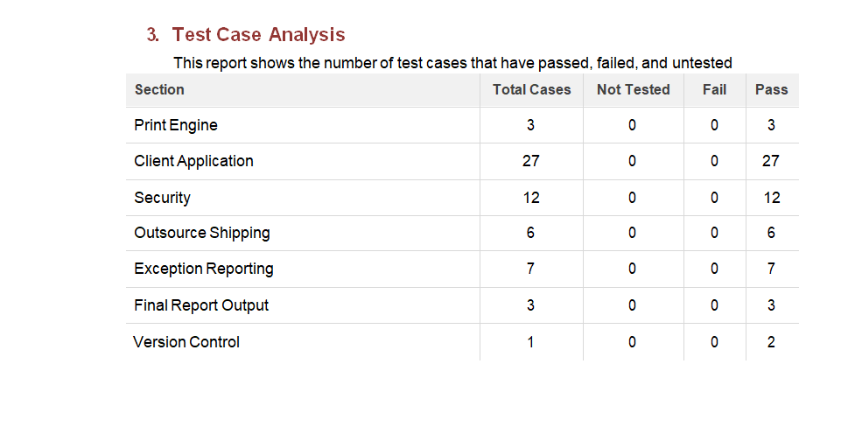**9.RESULTS**

**9.1 PERFORMANCE TESTING**

**10.ADVANTAGES&DISADVANTAGES**

**advantages**

- Real-time plant monitoring

- Reduced risks of disasters

- Automated detection

- Excellent customer experience

- Improved asset utilization

- Enhanced revenue

**Disadvantages**

In hazardous areas, **the presence of flammable gas, vapor, liquid, or dust can bring major risk to the activity of an electrical device**, as there is the prospect that the device could ignite the flammable substance

**11.CONCLUSION**

This work shows the design of a new wearable device for the detection of some toxic and explosive gases. From the tests it was shown that even using a cheap and low power electronic system and standard commercial sensors it is possible to obtain sufficient measurement accuracy to implement safety monitoring for hazardous areas. Compared with the most diffused commercial devices, the developed sensor node can operate for one working week without recharging its battery. The system can host different sensor types allowing to read almost all available commercial sensors for portable devices. Moreover, it implements a long-range communication protocol that, at the same time, allows to transmit data in a range able to cover the area of typical Oil&gas or chemical plants (1-2 km depending on area morphology) and save battery energy. The wireless network is scalable, with additional gateways it is possible to increase the operating area without changing the system architecture. Future developments will be performed in the server side, implementing specific data post processing, also based on Machine Learning algorithms, integrating data coming also from other sensors that can be already present on the plant to automatically detect the insurgence of critical situations.

**12.FUTURE SCOPE**

ABB has extended the scope of applications for ABB Smart Sensors with a new generation design for motors in **hazardous areas. Chemical and oil and gas customers can** now benefit from cost-efficient condition monitoring in a wide variety of applications.

“Our new generation of smart sensors provide high quality data to enable ABB’s advanced analytics to be used in hazardous areas,” says Teijo Kärnä, Global Product Manager, ABB Ability™ Smart Sensor. “These smart sensors are more sensitive which allows customers to see problems earlier. They also offer more monitoring capabilities, a broader communication range and exceptional battery life.”